ShopNest Dash Board Report
ShopNest Dashboard Overview
This dashboard shows how the ShopNest Store performed between 2016 and 2018. It tells us about sales, orders, and customer trends.
Key Numbers (KPIs)
- Total Customers (98.239K): More than 98,000 customers shopped from the store.
- Total Sales (13.44M): The store made a total money of 13.44 Million.
- Total Orders (98K): Customers placed 98,000 orders in total.
- AOV (136.80): This is the Average Order Value. It means on average, one customer spends 136.80 in one order. It is calculated by dividing total sales by unique orders.
Year-by-Year Growth
- Orders Trend: Orders were very low in 2016, but they grew quickly to 45K in 2017, and reached the highest at 53K in 2018.
- Sales Trend: Just like orders, sales also went up. Sales were 0.0M in 2016, jumped to 6.1M in 2017, and hit the highest at 7.3M in 2018.
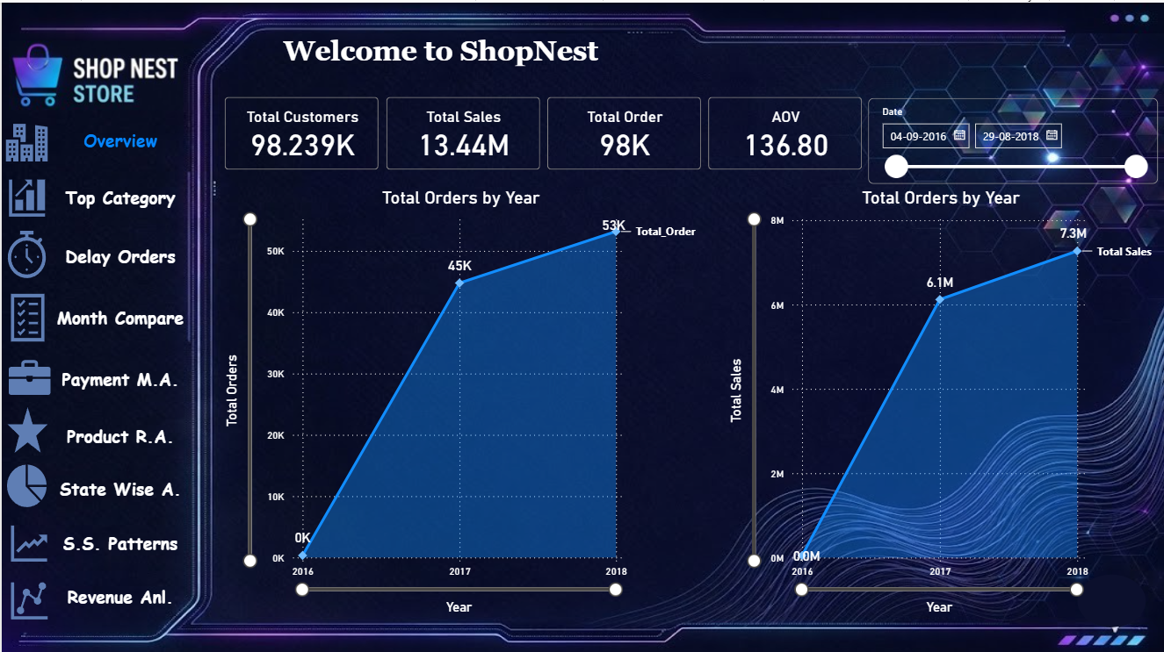

Question Statement 1: Top Categories by Total Price:
- Identify and visually represent the top 10 product categories by total sales.
Clear Representation: -
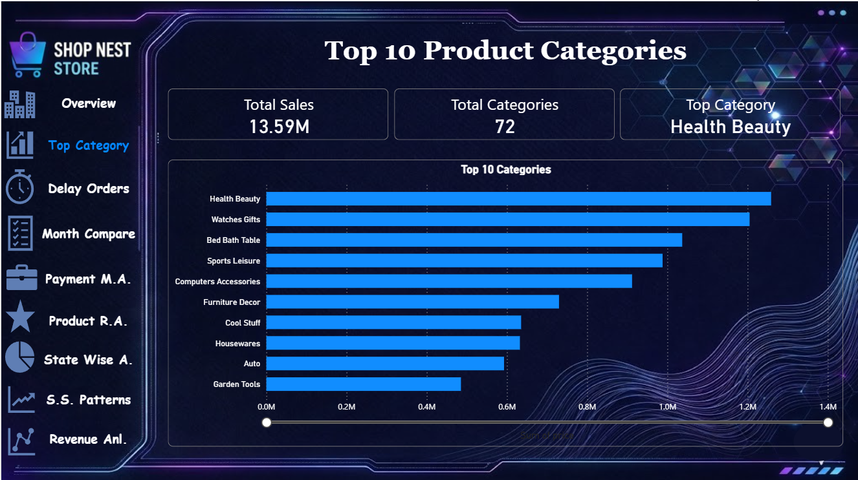
Explanation:
- Total Sales & Categories: The store has a total of 72 product categories, making a total sales of 13.59 Million.
- Number 1 Category: "Health Beauty" is the best-selling category. It made the highest sales (around 1.2M to 1.3M).
- Other Top Winners: "Watches Gifts", "Bed Bath Table", and "Sports Leisure" are also very popular and bring in huge sales.
- Lowest in Top 10: "Garden Tools" is at number 10, making the lowest sales among the top categories (around 0.5M).
- Main Finding: Health, beauty, and gift items are driving the most money for ShopNest Store.

Question Statement 2 :- Delayed Orders Analysis:
Determine the number of delayed orders in each category. An order is considered delayed if the actual delivery date is later than the estimated delivery date.
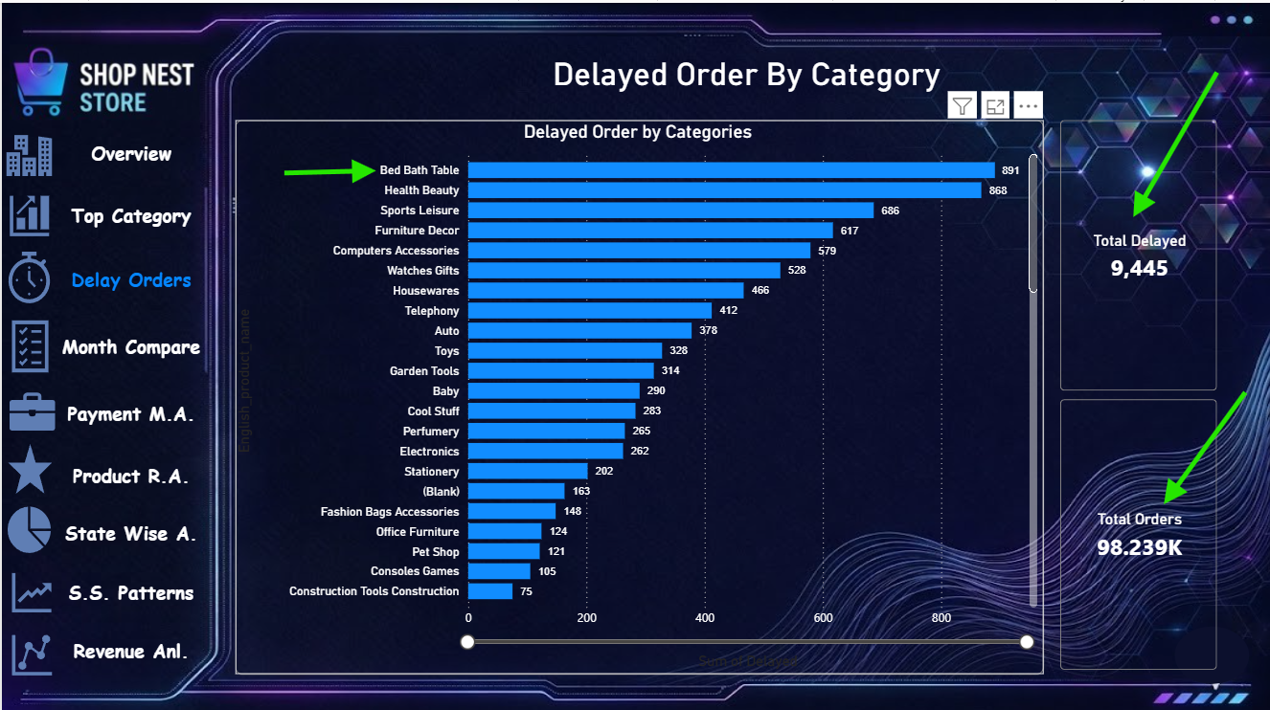
Explanation:
- Total Delayed Orders: Out of 98.239K total orders, 9,445 orders were delivered late.
- Worst Category (Highest Delays): "Bed Bath Table" has the highest number of late deliveries with 891 delayed orders.
- Second Worst: "Health Beauty" is very close behind with 868 delayed orders.
- Other Big Trouble Areas: "Sports Leisure" (686) and "Furniture Decor" (617) also have a high number of late deliveries.
- Main Finding: Heavy and popular items like bed/bath products and beauty items face the most shipping delays.

Question Statement 3: Monthly Comparison of Delayed and On-Time Orders
Create a dynamic visual that compares the number of delayed orders to the number of orders received earlier for each month. Utilize filters/slicers to provide a detailed analysis of late and on-time deliveries.
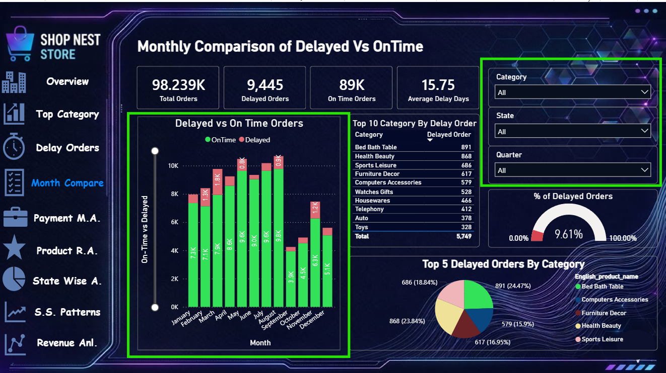Explanation:
- Main Numbers (KPIs): * Out of 98.239K Total Orders, 89K orders were delivered on time, while 9,445 orders were delayed.
  - On average, late orders take 15.75 days to deliver. The total percentage of delayed orders is 9.61%.
- Monthly Trend (Bar Chart): * The bar chart compares green bars (On-Time) and red bars (Delayed) for each month.
  - Highest Orders: Months like May (9.6K) and August (9.8K) have the highest number of successful on-time orders.
  - Highest Delays: March (1.3K) and December (1.2K) show large red bars, meaning these months face major delivery bottlenecks.
- Top 5 Delayed Categories (Pie Chart):
  - "Bed Bath Table" is the biggest problem, making up 24.47% of total delays, followed closely by "Health Beauty" at 23.84%.

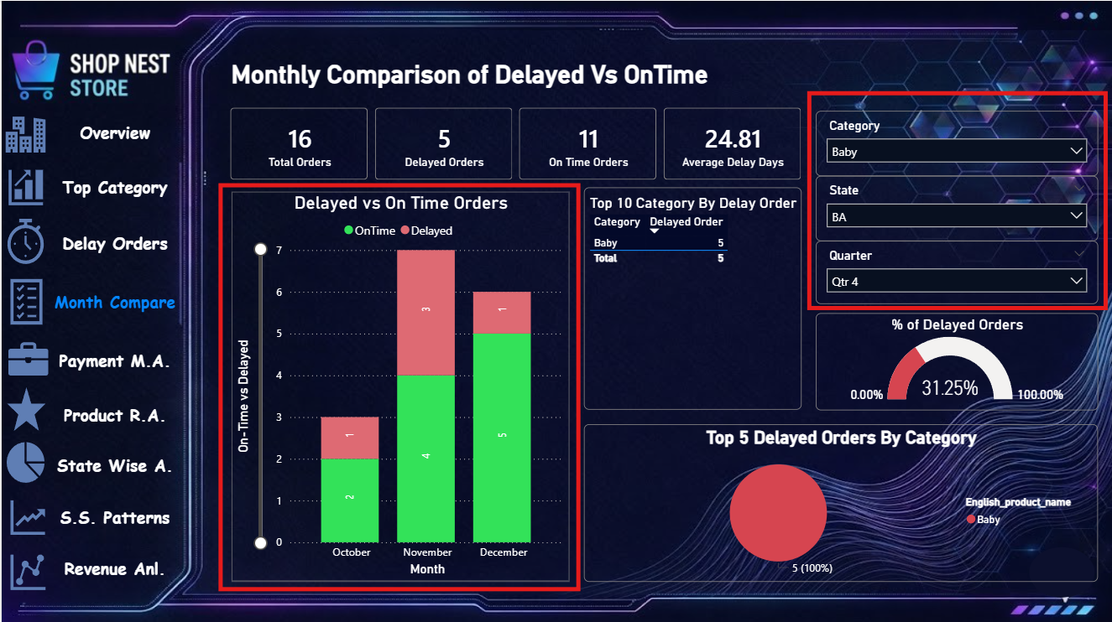
Interactive Slicers Used:
- Category Slicer: Allows stakeholders to filter data for a specific item type (like Art, Baby, or Bed Bath Table).
- State Slicer: Helps to track performance by regional codes (like AC, AL, AM, AP) to see which locations have worse delay rates.
- Quarter Slicer: Filters the entire screen by specific quarters (Qtr 1 to Qtr 4) to track seasonal delivery efficiency.

Question Statement 4 :- Payment Method Analysis:
Analyze the most frequently used payment methods by customers using a visually appealing representation, such as a pie chart or other suitable visuals
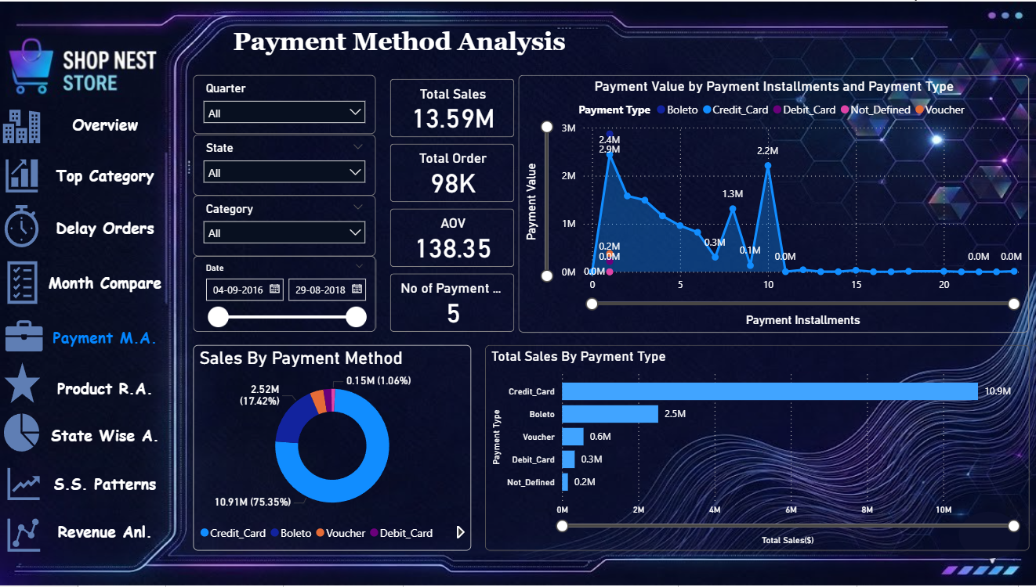
Explanation:
- Most Popular Payment: Credit Card is the absolute favorite choice for customers. It brings in 10.91M in sales, which is 75.35% (more than half!) of all transactions.
- Second Choice: Boleto comes at number two, making 2.52M in sales (17.42%).
- Least Used Options: Other methods like Voucher (0.6M), Debit Card (0.3M), and Not_Defined (0.2M) are rarely used by customers.
- Installments Trend: The line chart shows that customers love to buy using small installments. The biggest sales spikes happen when customers pay in 1, 2, or 10 installments.
- Main Finding: Most of the money in ShopNest comes from Credit Cards and split payments (installments).
Slicers Used:
- Quarter Slicer: Used to check payment choices for specific parts of the year.
- State Slicer: Helps to see if customers in different locations prefer different payment methods.
- Category Slicer: Used to look at what payment method is popular for specific.
- Date Slicer: A timeline slider to change the date range and check changing payment habits over time.
Question Statement 5 :- Product Rating Analysis:
Determine the top 10 highest-rated products and the bottom 10 lowest-rated products using a bar or column chart.
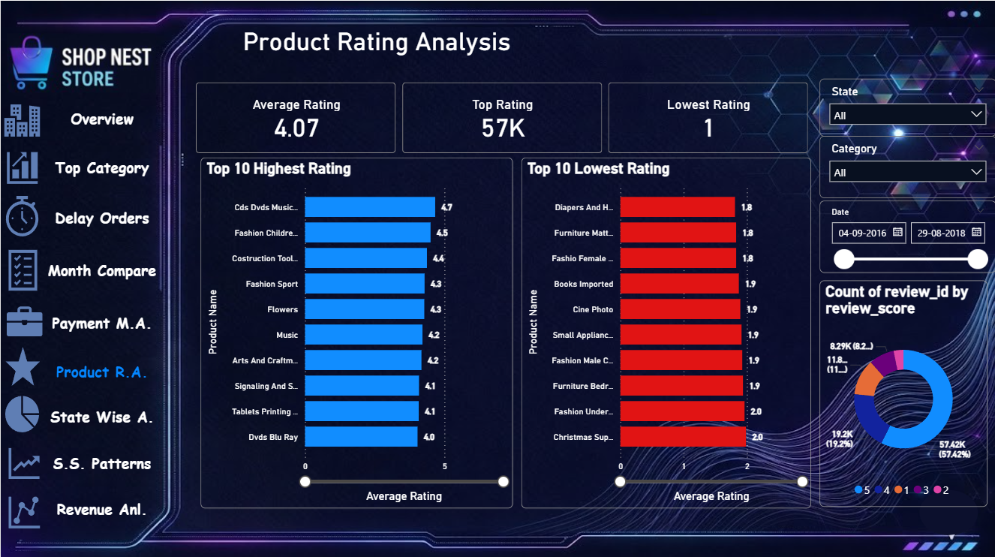

Explanation:
- Overall Performance: The overall Average Rating of the store is pretty good, standing at 4.07 out of 5. There are 57K Top Ratings given by customers, while the lowest score received is 1.
- Top 10 Winners (Blue Chart): "Cds Dvds Music" is the highest-rated product with a 4.7 rating. Other high scorers include Fashion Children, Construction Tools, and Fashion Sport.
- Bottom 10 Losers (Red Chart): "Diapers And Hygiene" and "Furniture Mattress." are the worst-rated items with a very low 1.8 rating. These products need immediate quality checks.
- Rating Distribution (Donut Chart): The majority of customer reviews are highly positive, with 57.42K reviews giving a perfect 5-star rating (blue section).
Slicers Used:
- State Slicer: Used to check product feedback in specific locations to see if a product is underperforming in a particular city or region.
- Category Slicer: Helps filter and compare ratings between entirely different product segments.
- Date Slicer: A timeline slider to see how customer ratings and reviews are changing month-by-month or year-by-year.

Question Statement 6: State-wise Sales Analysis
Identify and visually represent states with high and low sales, providing a clear understanding of regional sales performance.
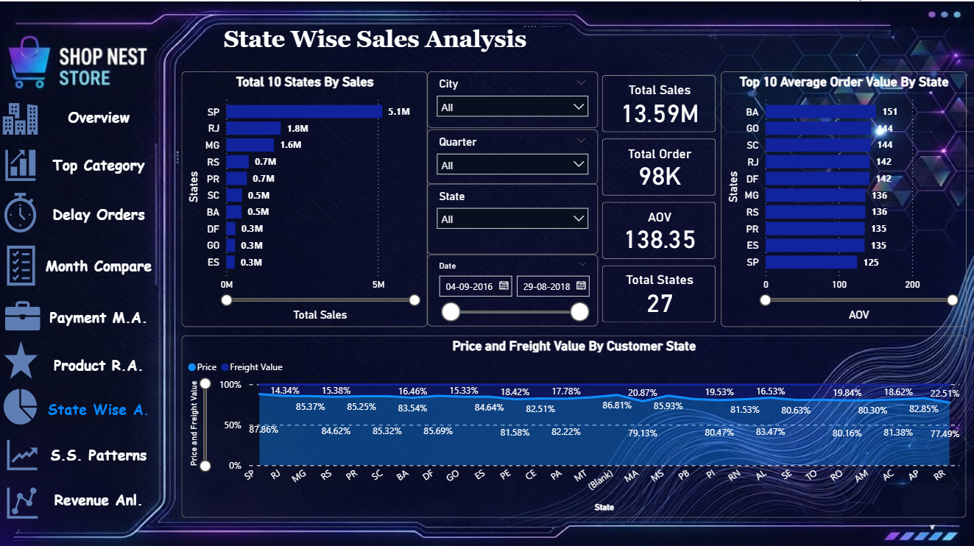
Explanation:
- Overall Market: The store operates across 27 Total States, making a total sales of 13.59M with 98K orders.
- Highest Sales (Left Chart): "SP" is the biggest king market, making a huge 5.1M in sales. RJ (1.8M) and MG (1.6M) are also high-performing states.
- Lowest Sales: States at the bottom like GO, ES, and DF make very low sales, around 0.3M each.
- Top 10 Average Order Value (Right Chart): This chart shows the top 10 states where the average order size is highest. "BA" is leading this list with an average order value of 151, followed by GO (144) and SC (144). This means customers from these states buy more expensive items per order.
- Price vs Freight: The bottom line chart shows the product price and shipping cost (freight value) for each state.
Slicers Used:
- City Slicer: Used to check sales details down to a specific city level within any state.
- Quarter Slicer: Helps to see regional sales performance during different times/quarters of the year.
- State Slicer: Selects one particular state to focus on its data immediately.
- Date Slicer: A slider to track how regional sales have grown or dropped over time.

Question Statement 7:- Seasonal Sales Patterns
Investigate and visualize any seasonal patterns (Quarterly) or trends in sales data over the course of the year.
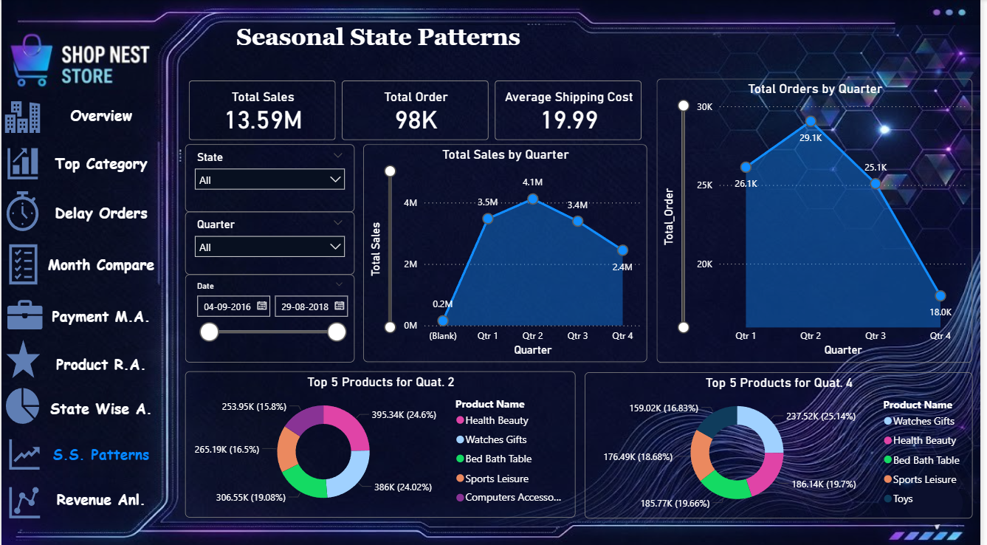
Explanation:
- Main KPIs: The store has a total sales of 13.59M, with 98K orders. The Average Shipping Cost paid by customers is 19.99.
- Best Quarter (Peak Season): Quarter 2 (Qtr 2) is the absolute best time for the store. Sales hit the highest at 4.1M, and total orders peak at 29.1K.
- Slowest Quarter (Low Season): Quarter 4 (Qtr 4) is the slowest time. Sales drop down to 2.4M, and orders drop significantly to 18.0K.
- Top Products Comparison:
  - In Quarter 2, "Health Beauty" is the number one product (making up 24.6% of the top items).
  - In Quarter 4, customer choice changes, and "Watches Gifts" becomes the number one product (making up 25.14% of the top items).
Slicers Used:
- State Slicer: Helps to see if different states have different seasonal shopping habits.
- Quarter Slicer: Used to filter the charts and focus on a single quarter's performance.
- Date Slicer: A timeline slider to change the years and check if the same quarterly trends happen every year.

Question Statement 8:- Revenue Analysis
Determine the total revenue generated by ShopNest Store and analyze how it changes over time (Yearly). Represent this information through suitable visuals to highlight trends and patterns.
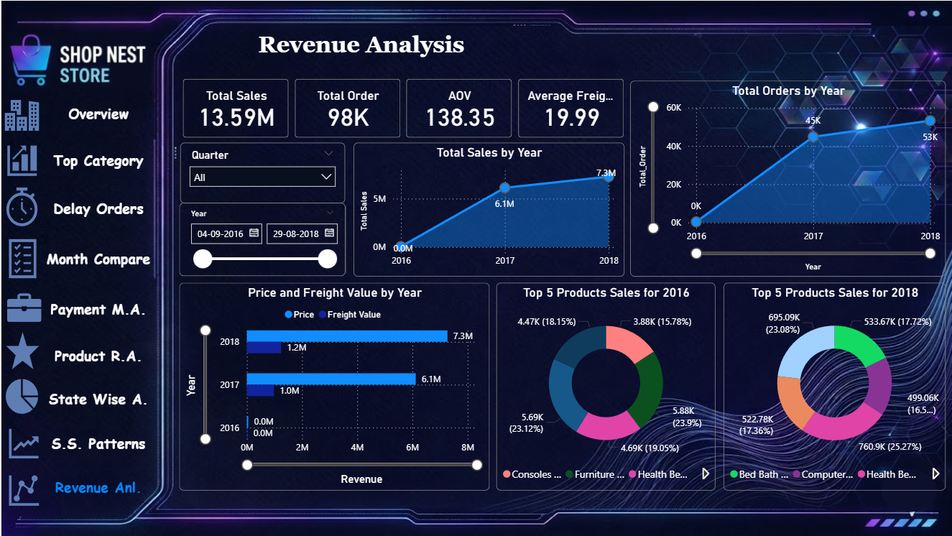
Explanation:
- Main KPIs: The store made a total revenue of 13.59M sales with 98K orders. The Average Order Value (AOV) is 138.35, and the Average Freight (shipping cost) is 19.99.
- Yearly Growth Trend: * Sales and orders grew very fast. In 2016, the store made almost 0.0M sales because it started late in the year.
  - In 2017, sales jumped up heavily to 6.1M (with 45K orders).
  - In 2018, the store hit its highest peak with 7.3M in sales (with 53K orders).
- Price vs Freight (Bar Chart): In both 2017 and 2018, as product sales (light blue bar) went up, the shipping/freight costs (dark blue bar) also increased naturally to manage more deliveries.
- Changing Top Products: * In 2016, items like "Consoles" and "Furniture" were the top earners.
  - By 2018, customer trends changed completely, and "Health Beauty" became the biggest king product earning 760.9K (25.27%).
Slicers Used:
- Quarter Slicer: Used to check the revenue details for specific months or quarters within each year.
- Year/Date Slicer: A timeline filter to easily change and compare the data ranges between 2016, 2017, and 2018.

